BRACT’s

Vishwakarma Institute of Technology, Pune

Practical Implementation Sheet

Department: CSE-AI Semester: 5 Academic Year: 2026-27

Practical No: 7
Division: C Batch: 3

Roll No: 69 PRN No: 12415121

Name of Student: Kunal Patil
Subject Name: Deep Learning

Problem Statement:
Implement transfer learning using pre-trained AlexNet, VGG16, ResNet50, and EfficientNetB0 models for image classification, and compare their performance.

Algorithm :

Introduction
Transfer learning is a deep learning technique in which a model that has already been trained on a large dataset is reused for a new but related task.
Instead of training a deep neural network from the beginning, a pretrained model can be used as a feature extractor. The pretrained layers have already learned useful features such as:
- Edges
- Corners
- Textures
- Shapes
- Patterns
- Object structures

These learned features can then be used for classification on a new dataset.
In this experiment, the CIFAR-10 dataset is used for image classification. Four popular CNN architectures are compared:
- AlexNet
- VGG16
- ResNet50

- EfficientNetB0

CIFAR-10 Dataset
CIFAR-10 is a commonly used image classification dataset containing 60,000 color images belonging to 10 classes.
Each original image has a resolution of:
32 × 32 × 3
The ten classes are:
Class | Description
0 | Airplane
1 | Automobile
2 | Bird
3 | Cat
4 | Deer
5 | Dog
6 | Frog
7 | Horse
8 | Ship
9 | Truck

For this experiment, a smaller subset is used to reduce computational and memory requirements:
- Training samples: 5000
- Validation samples: 1000
- Test samples: 1000
The CIFAR-10 images are resized from 32 × 32 to 224 × 224, because VGG16, ResNet50 and the chosen AlexNet architecture operate with larger image inputs.

Models Used AlexNet
AlexNet is a convolutional neural network introduced by Alex Krizhevsky, Ilya Sutskever, and Geoffrey Hinton.
Its architecture contains:
- Convolutional layers
- ReLU activation
- Max-pooling layers
- Fully connected layers
- Dropout
AlexNet played an important role in demonstrating the effectiveness of deep CNNs for image classification.

VGG16
VGG16 is a deep convolutional neural network developed by the Visual Geometry Group at the University of Oxford.
It contains:
- 13 convolutional layers

- 3 fully connected layers
- 16 weight layers in total VGG16 primarily uses small:
3 × 3 convolution filters
The pretrained VGG16 model used in this experiment has been trained on ImageNet.
The convolutional base is frozen, meaning its pretrained weights are not changed during initial training.

ResNet50
ResNet50 is a deep CNN architecture based on residual learning. It contains approximately 50 layers.
The major innovation of ResNet is the residual/skip connection. Instead of directly learning:
a residual block learns:
and then produces:
Skip connections help reduce the vanishing-gradient problem and allow very deep neural networks to be trained effectively.
In this experiment, ResNet50 uses ImageNet pretrained weights.

EfficientNetB0
EfficientNet is a family of CNN models designed to provide a good balance between:
  - Accuracy
  - Number of parameters
  - Computational cost
EfficientNet uses a technique called compound scaling, which scales:
  - Network depth
  - Network width
  - Image resolution in a coordinated way.
EfficientNetB0 is the baseline model of the EfficientNet family.
It is generally much more parameter-efficient than older architectures while providing strong classification performance.

Evaluation Metrics
The models are compared using several metrics.

Accuracy
Accuracy represents the percentage of correctly classified images.
𝐶𝑜𝑟𝑟𝑒𝑐𝑡 𝑃𝑟𝑒𝑑𝑖𝑐𝑡𝑖𝑜𝑛𝑠

Precision
𝐴𝑐𝑐𝑢𝑟𝑎𝑐𝑦 =

𝑇𝑜𝑡𝑎𝑙 𝑃𝑟𝑒𝑑𝑖𝑐𝑡𝑖𝑜𝑛𝑠

Precision measures how many predicted positive samples are actually correct.
𝑇𝑃

Recall
𝑃𝑟𝑒𝑐𝑖𝑠𝑖𝑜𝑛 =

𝑇𝑃 + 𝐹𝑃

Recall measures how many actual positive samples are correctly identified.

F1-score
𝑅𝑒𝑐𝑎𝑙𝑙 =
𝑇𝑃

𝑇𝑃 + 𝐹𝑁

F1-score combines precision and recall.
𝐹1 = 2 ×

Code :
𝑃𝑟𝑒𝑐𝑖𝑠𝑖𝑜𝑛 × 𝑅𝑒𝑐𝑎𝑙𝑙

𝑃𝑟𝑒𝑐𝑖𝑠𝑖𝑜𝑛 + 𝑅𝑒𝑐𝑎𝑙𝑙

# TRANSFER LEARNING USING PRETRAINED:
# AlexNet, VGG16, ResNet50, EfficientNetB0 # Dataset: CIFAR-10

import torch
import torch.nn as nn import torch.optim as optim
from torch.utils.data import DataLoader, Subset import torchvision
import torchvision.transforms as transforms from torchvision import models
import numpy as np import pandas as pd
import matplotlib.pyplot as plt import seaborn as sns
import time import copy import gc
from sklearn.model_selection import train_test_split
from sklearn.metrics import confusion_matrix, classification_report

device = torch.device("cuda" if torch.cuda.is_available() else "cpu") print("Using device:", device)

IMG_SIZE = 224
BATCH_SIZE = 16
EPOCHS = 3
NUM_CLASSES = 10
TRAIN_SAMPLES = 5000
TEST_SAMPLES = 1000
RANDOM_STATE = 42
LEARNING_RATE = 0.001

class_names = [

"airplane", "automobile", "bird", "cat", "deer",
"dog", "frog", "horse", "ship", "truck"
]

# ImageNet pretrained models expect normalized RGB images. train_transform = transforms.Compose([
transforms.Resize((IMG_SIZE, IMG_SIZE)), transforms.RandomHorizontalFlip(), transforms.ToTensor(), transforms.Normalize(
mean=[0.485, 0.456, 0.406],
std=[0.229, 0.224, 0.225]
)
])

test_transform = transforms.Compose([ transforms.Resize((IMG_SIZE, IMG_SIZE)), transforms.ToTensor(), transforms.Normalize(
mean=[0.485, 0.456, 0.406],
std=[0.229, 0.224, 0.225]
)
])

# LOAD CIFAR-10
full_train_dataset = torchvision.datasets.CIFAR10( root="./data",
train=True, download=True, transform=train_transform
)

# Separate copy without augmentation for validation full_train_dataset_no_aug = torchvision.datasets.CIFAR10(
root="./data", train=True, download=True, transform=test_transform
)

full_test_dataset = torchvision.datasets.CIFAR10( root="./data",
train=False, download=True,

transform=test_transform
)

# TRAIN / VALIDATION SPLIT
train_indices = np.arange(TRAIN_SAMPLES) test_indices = np.arange(TEST_SAMPLES)

all_labels = np.array(full_train_dataset.targets)[train_indices]

train_idx, val_idx = train_test_split( train_indices,
test_size=0.20, random_state=RANDOM_STATE, stratify=all_labels
)

train_dataset = Subset(full_train_dataset, train_idx) val_dataset = Subset(full_train_dataset_no_aug, val_idx) test_dataset = Subset(full_test_dataset, test_indices)

train_loader = DataLoader( train_dataset, batch_size=BATCH_SIZE, shuffle=True, num_workers=0
)

val_loader = DataLoader( val_dataset, batch_size=BATCH_SIZE, shuffle=False, num_workers=0
)

test_loader = DataLoader( test_dataset, batch_size=BATCH_SIZE, shuffle=False, num_workers=0
)

print("Training images:", len(train_dataset)) print("Validation images:", len(val_dataset)) print("Testing images:", len(test_dataset))

# LOAD PRETRAINED MODELS
def get_pretrained_model(model_name):

if model_name == "AlexNet": print("\nLoading pretrained AlexNet...") model = models.alexnet(
weights=models.AlexNet_Weights.DEFAULT
)

# Freeze all pretrained parameters for param in model.parameters():
param.requires_grad = False

# Replace ImageNet 1000-class output with CIFAR-10 10-class output input_features = model.classifier[6].in_features model.classifier[6] = nn.Linear(
input_features, NUM_CLASSES
)

elif model_name == "VGG16": print("\nLoading pretrained VGG16...") model = models.vgg16(
weights=models.VGG16_Weights.DEFAULT
)

# Freeze all pretrained parameters for param in model.parameters():
param.requires_grad = False

input_features = model.classifier[6].in_features model.classifier[6] = nn.Linear(
input_features, NUM_CLASSES
)

elif model_name == "ResNet50": print("\nLoading pretrained ResNet50...") model = models.resnet50(
weights=models.ResNet50_Weights.DEFAULT
)

# Freeze all pretrained parameters for param in model.parameters():
param.requires_grad = False

input_features = model.fc.in_features model.fc = nn.Linear(
input_features, NUM_CLASSES
)

elif model_name == "EfficientNetB0": print("\nLoading pretrained EfficientNetB0...") model = models.efficientnet_b0(
weights=models.EfficientNet_B0_Weights.DEFAULT
)

# Freeze all pretrained parameters for param in model.parameters():
param.requires_grad = False

input_features = model.classifier[1].in_features model.classifier[1] = nn.Linear(
input_features, NUM_CLASSES
)

else:
raise ValueError("Unknown model name")

return model.to(device)

# TRAINING FUNCTION
def train_model(model, train_loader, val_loader, epochs):

criterion = nn.CrossEntropyLoss()

# Only the newly added classifier layer is trainable optimizer = optim.Adam(
filter(lambda p: p.requires_grad, model.parameters()), lr=LEARNING_RATE
)

history = {
"train_loss": [], "train_accuracy": [], "val_loss": [], "val_accuracy": []
}

best_val_accuracy = 0.0
best_weights = copy.deepcopy(model.state_dict())

start_time = time.time()

for epoch in range(epochs):

print(f"\nEpoch {epoch + 1}/{epochs}")

# TRAIN
model.train()

running_loss = 0.0
correct = 0
total = 0

for images, labels in train_loader:

images = images.to(device) labels = labels.to(device)

optimizer.zero_grad()

outputs = model(images)
loss = criterion(outputs, labels)

loss.backward() optimizer.step()

running_loss += loss.item() * images.size(0)

_, predicted = torch.max(outputs, 1)

total += labels.size(0)
correct += (predicted == labels).sum().item()

train_loss = running_loss / total train_accuracy = correct / total

# VALIDATION
model.eval()

val_loss_total = 0.0
val_correct = 0
val_total = 0

with torch.no_grad():

for images, labels in val_loader:

images = images.to(device) labels = labels.to(device)

outputs = model(images)
loss = criterion(outputs, labels)

val_loss_total += loss.item() * images.size(0)

_, predicted = torch.max(outputs, 1)

val_total += labels.size(0)
val_correct += (predicted == labels).sum().item()

val_loss = val_loss_total / val_total val_accuracy = val_correct / val_total

history["train_loss"].append(train_loss) history["train_accuracy"].append(train_accuracy) history["val_loss"].append(val_loss) history["val_accuracy"].append(val_accuracy)

if val_accuracy > best_val_accuracy: best_val_accuracy = val_accuracy
best_weights = copy.deepcopy(model.state_dict())

print(
f"Train Loss: {train_loss:.4f} | "
f"Train Accuracy: {train_accuracy * 100:.2f}%"
)
print(
f"Val Loss: {val_loss:.4f} | "
f"Val Accuracy: {val_accuracy * 100:.2f}%"
)

training_time = time.time() - start_time

# Restore best validation model model.load_state_dict(best_weights)

return model, history, training_time

# TEST FUNCTION
def evaluate_model(model, test_loader):

model.eval()

criterion = nn.CrossEntropyLoss()

total_loss = 0.0
correct = 0
total = 0

all_labels = [] all_predictions = []

with torch.no_grad():

for images, labels in test_loader:

images = images.to(device) labels = labels.to(device)

outputs = model(images)
loss = criterion(outputs, labels)

total_loss += loss.item() * images.size(0)

_, predicted = torch.max(outputs, 1)

total += labels.size(0)
correct += (predicted == labels).sum().item()

all_labels.extend(labels.cpu().numpy()) all_predictions.extend(predicted.cpu().numpy())

accuracy = correct / total test_loss = total_loss / total

return (
accuracy, test_loss,
np.array(all_labels), np.array(all_predictions)
)

# RUN ALL FOUR MODELS
model_names = [ "AlexNet", "VGG16",
"ResNet50", "EfficientNetB0"
]

results = [] histories = {} true_labels = {} predictions = {}

for model_name in model_names:

print("\n" + "=" * 70) print("MODEL:", model_name) print("=" * 70)

model = get_pretrained_model(model_name)

model, history, training_time = train_model( model,
train_loader, val_loader, EPOCHS
)

accuracy, test_loss, y_true, y_pred = evaluate_model( model,
test_loader
)

histories[model_name] = history true_labels[model_name] = y_true predictions[model_name] = y_pred

results.append({ "Model": model_name,
"Test Accuracy": accuracy, "Test Loss": test_loss,
"Training Time (sec)": training_time
})

print("\nTest Accuracy:", f"{accuracy * 100:.2f}%") print("Test Loss:", f"{test_loss:.4f}") print("Training Time:", f"{training_time:.2f} seconds")

# Free memory before loading next model del model
gc.collect()

if torch.cuda.is_available(): torch.cuda.empty_cache()

# RESULTS TABLE
results_df = pd.DataFrame(results)

results_df["Accuracy (%)"] = ( results_df["Test Accuracy"] * 100
)

print("\n" + "=" * 70) print("FINAL MODEL COMPARISON")
print("=" * 70)

print(
results_df[
[
"Model", "Accuracy (%)", "Test Loss",
"Training Time (sec)"
]
].round(4).to_string(index=False)
)

# BEST MODEL
best_row = results_df.loc[ results_df["Test Accuracy"].idxmax()
]

print("\nBest Model:", best_row["Model"]) print(
"Best Accuracy:", f"{best_row['Accuracy (%)']:.2f}%"

)

# ACCURACY GRAPH
plt.figure(figsize=(10, 6))

plt.bar(
results_df["Model"], results_df["Accuracy (%)"]
)

plt.title("Transfer Learning Model Accuracy Comparison") plt.xlabel("Model")
plt.ylabel("Test Accuracy (%)") plt.ylim(0, 100) plt.xticks(rotation=20) plt.tight_layout()
plt.show()

# TRAINING TIME GRAPH
plt.figure(figsize=(10, 6))

plt.bar(
results_df["Model"], results_df["Training Time (sec)"]
)

plt.title("Training Time Comparison") plt.xlabel("Model") plt.ylabel("Training Time (seconds)") plt.xticks(rotation=20) plt.tight_layout()
plt.show()

# ACCURACY CURVES
for model_name in model_names:

history = histories[model_name]

epochs_range = range( 1,
len(history["train_accuracy"]) + 1
)

plt.figure(figsize=(8, 5))

plt.plot(
epochs_range, history["train_accuracy"], marker="o", label="Training Accuracy"
)

plt.plot(
epochs_range, history["val_accuracy"], marker="o", label="Validation Accuracy"
)

plt.title(
model_name + " - Training vs Validation Accuracy"
)

plt.xlabel("Epoch") plt.ylabel("Accuracy") plt.legend() plt.grid(True) plt.tight_layout() plt.show()

# LOSS CURVES
for model_name in model_names:

history = histories[model_name]

epochs_range = range( 1,
len(history["train_loss"]) + 1
)

plt.figure(figsize=(8, 5))

plt.plot(
epochs_range, history["train_loss"], marker="o",

label="Training Loss"
)

plt.plot(
epochs_range, history["val_loss"], marker="o", label="Validation Loss"
)

plt.title(
model_name + " - Training vs Validation Loss"
)

plt.xlabel("Epoch") plt.ylabel("Loss") plt.legend() plt.grid(True) plt.tight_layout() plt.show()

# CONFUSION MATRICES
for model_name in model_names:

y_true = true_labels[model_name] y_pred = predictions[model_name]

cm = confusion_matrix( y_true,
y_pred
)

plt.figure(figsize=(10, 8))

sns.heatmap( cm, annot=True, fmt="d",
cmap="Blues", xticklabels=class_names, yticklabels=class_names
)

plt.title(

model_name + " - Confusion Matrix"
)

plt.xlabel("Predicted Class") plt.ylabel("Actual Class") plt.tight_layout() plt.show()

# CLASSIFICATION REPORTS
for model_name in model_names:

print("\n" + "=" * 70) print("CLASSIFICATION REPORT:", model_name) print("=" * 70)

print(
classification_report( true_labels[model_name], predictions[model_name], target_names=class_names
)
)

# FINAL CONCLUSION
best_accuracy_model = results_df.loc[ results_df["Test Accuracy"].idxmax(), "Model"
]

fastest_model = results_df.loc[ results_df["Training Time (sec)"].idxmin(), "Model"
]

print("\n" + "=" * 80) print("CONCLUSION")
print("=" * 80)

print(
"Best performing model:", best_accuracy_model
)

print(

"Fastest model:", fastest_model
)

Output :
Using device: cuda

100%|██████████| 170M/170M [01:42<00:00, 1.66MB/s]

Training images: 4000

Validation images: 1000

Testing images: 1000

MODEL: AlexNet

======================================================================

Loading pretrained AlexNet...

Downloading: "https://download.pytorch.org/models/alexnet-owt-7be5be79.pth" to
/root/.cache/torch/hub/checkpoints/alexnet-owt-7be5be79.pth 100%|██████████| 233M/233M [00:01<00:00, 175MB/s] Epoch 1/3
Train Loss: 0.9454 | Train Accuracy: 66.77% Val Loss: 0.7780 | Val Accuracy: 74.40%

Epoch 2/3

Train Loss: 0.6774 | Train Accuracy: 76.92% Val Loss: 0.6886 | Val Accuracy: 76.60%

Epoch 3/3

Train Loss: 0.5571 | Train Accuracy: 80.15% Val Loss: 0.6859 | Val Accuracy: 78.30%

Test Accuracy: 76.20%

Test Loss: 0.7298

Training Time: 29.85 seconds

MODEL: VGG16

======================================================================

Loading pretrained VGG16...

Downloading: "https://download.pytorch.org/models/vgg16-397923af.pth" to
/root/.cache/torch/hub/checkpoints/vgg16-397923af.pth 100%|██████████| 528M/528M [00:06<00:00, 83.8MB/s] Epoch 1/3
Train Loss: 0.8553 | Train Accuracy: 70.28% Val Loss: 0.6057 | Val Accuracy: 78.80%

Epoch 2/3

Train Loss: 0.6157 | Train Accuracy: 78.00% Val Loss: 0.5659 | Val Accuracy: 81.80%

Epoch 3/3

Train Loss: 0.5511 | Train Accuracy: 80.47% Val Loss: 0.5760 | Val Accuracy: 81.90%

Test Accuracy: 78.70%

Test Loss: 0.5900

Training Time: 89.80 seconds

MODEL: ResNet50

======================================================================

Loading pretrained ResNet50...

Downloading: "https://download.pytorch.org/models/resnet50-11ad3fa6.pth" to
/root/.cache/torch/hub/checkpoints/resnet50-11ad3fa6.pth 100%|██████████| 97.8M/97.8M [00:00<00:00, 190MB/s] Epoch 1/3
Train Loss: 1.3753 | Train Accuracy: 58.85% Val Loss: 0.9361 | Val Accuracy: 71.40%

Epoch 2/3

Train Loss: 0.8977 | Train Accuracy: 72.05% Val Loss: 0.7807 | Val Accuracy: 75.60%

Epoch 3/3

Train Loss: 0.7679 | Train Accuracy: 75.38% Val Loss: 0.7107 | Val Accuracy: 77.40%

Test Accuracy: 75.60%

Test Loss: 0.7445

Training Time: 70.72 seconds

MODEL: EfficientNetB0

======================================================================

Loading pretrained EfficientNetB0...

Downloading: "https://download.pytorch.org/models/efficientnet_b0_rwightman-7f5810bc.pth" to
/root/.cache/torch/hub/checkpoints/efficientnet_b0_rwightman-7f5810bc.pth

100%|██████████| 20.5M/20.5M [00:00<00:00, 158MB/s]

Epoch 1/3

Train Loss: 1.4657 | Train Accuracy: 56.33% Val Loss: 0.9876 | Val Accuracy: 73.50%

Epoch 2/3

Train Loss: 0.9843 | Train Accuracy: 69.33% Val Loss: 0.8094 | Val Accuracy: 75.30%

Epoch 3/3

Train Loss: 0.8712 | Train Accuracy: 72.55% Val Loss: 0.7612 | Val Accuracy: 76.80%

Test Accuracy: 76.80%

Test Loss: 0.7526

Training Time: 45.11 seconds

FINAL MODEL COMPARISON

======================================================================

Model Accuracy (%) Test Loss Training Time (sec)

AlexNet | 76.2 | 0.7298 | 29.8540
VGG16 | 78.7 | 0.5900 | 89.8005
ResNet50 | 75.6 | 0.7445 | 70.7202
EfficientNetB0 | 76.8 | 0.7526 | 45.1065

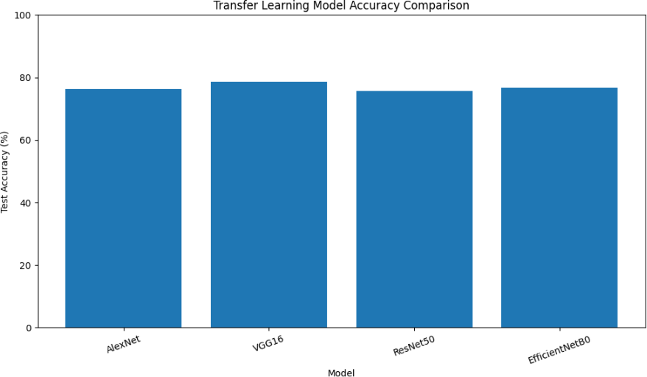
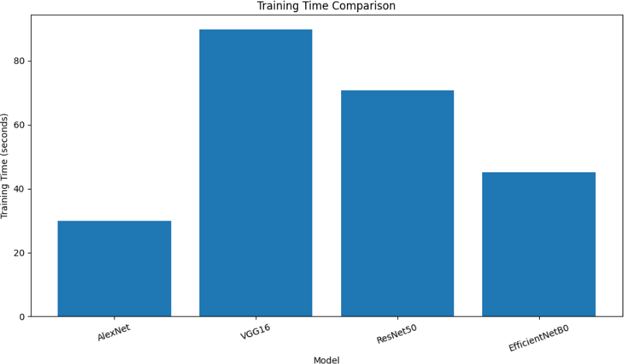
Best Model: VGG16 Best Accuracy: 78.70%

AlexNet - Training vs Validation Accuracy

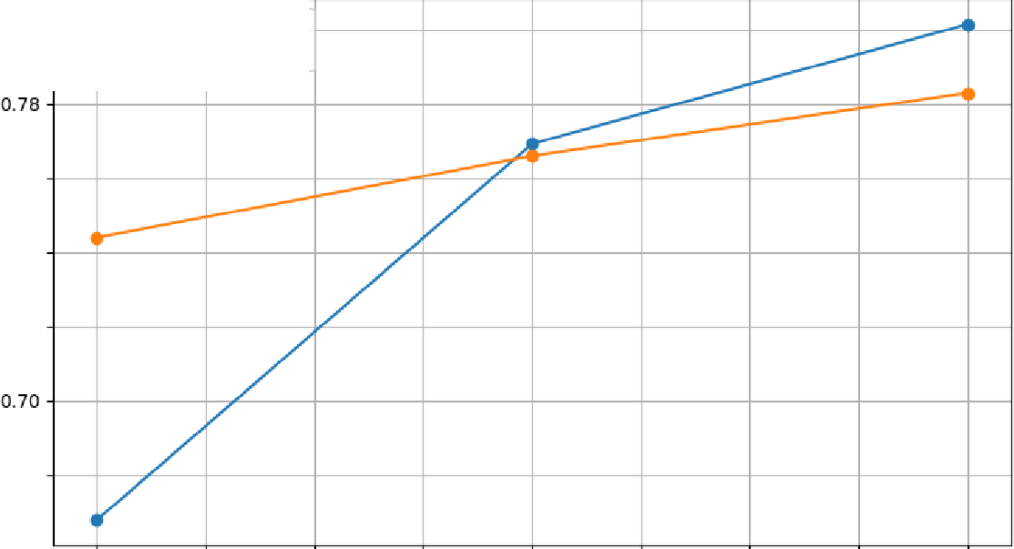
[
a.BO .....,._ Training Accuracy
-+- Validation Accuracy
0.76
0.74
0.72
0.68
a
:-t.

1.00 1.25 1.50 1.75 2.00
Epoch
2.25 2.50 2.75 3.00

VGG16 - Training vs Validation Accuracy

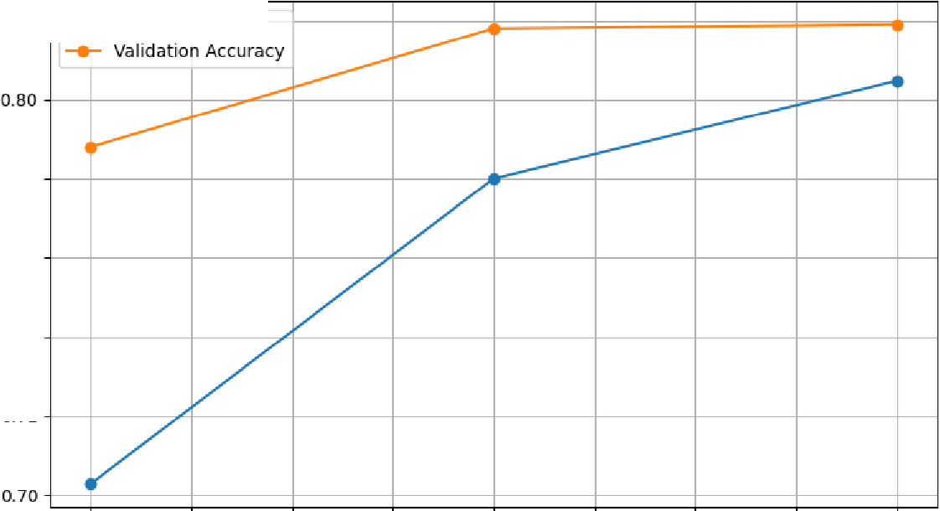
�
0.82 ... --e- Training Accuracy
0.78
0.76
0.74
0.72
�
�

1.00 1.25 1.50 1.75 2.00
Epoch
2.25 2.50 2.75 3.00

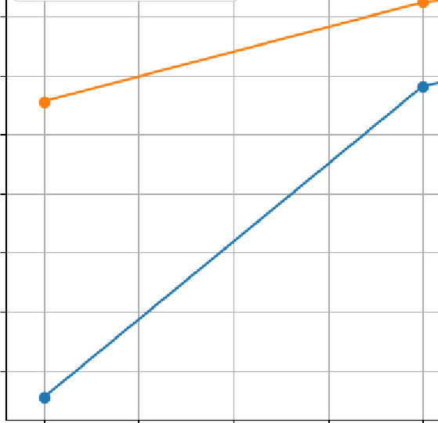
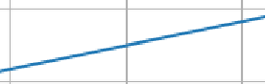
ResNet50 - Training vs Validation Accuracy
---1---1===r:===F=====f:::::==1-1

0.775 Training Accuracy
--e- Validation Accuracy
0.750

0.725

0.700
�
5u 0.675
:-t.
0.650

0.625

0.600

1.00 1.25 1.50 1.75 2.00
Epoch
2.25 2.50 2.75 3.00

u>-
�

0.75

0.70
EfficientNetBO - Training vs Validation Accuracy

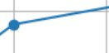

� 0.65

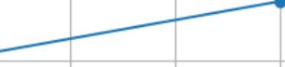
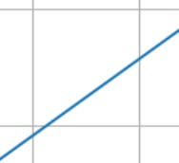
0.60
- Training Accuracy
- Validation Accuracy
t
t
+

1.00 1.25 1.50 1.75 2.00
Epoch
2.25 2.50 2.75 3.00

AlexNet - Training vs Validation Loss

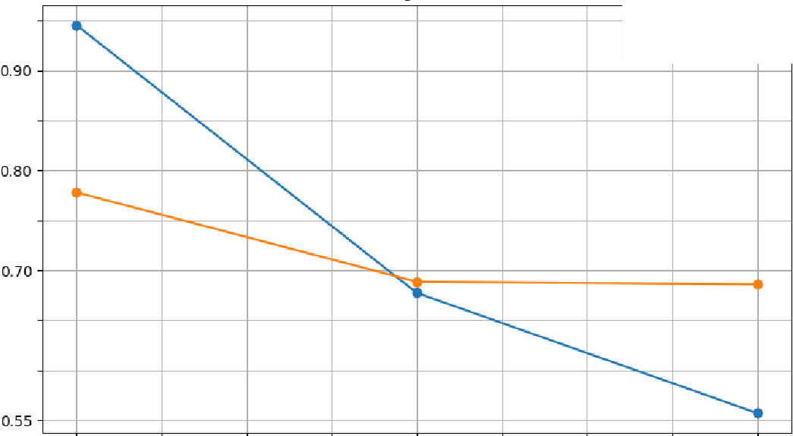
�
0.95
--e- Training Loss
....,..._ Validation Loss
0.85
0.75
0.65

0.60

1.00 1.25 1.50 1.75 2.00
Epoch
2.25 2.50 2.75 3.00

VGG16 - Training vs Validation Loss
,-
�
........- Training loss
........- Validation Loss
�
I
�
I
-
�
�
I
I"-.
�
I
.
-----
r--..
,
,_

1--r-
I
I
I
-

0.85

0.80

0.75

_g 0.70

0.65

0.60

0.55

1.00 1.25 1.50 1.75 2.00
Epoch

2.25 2.50 2.75 3.00

ResNet50 - Training vs Validation Loss
1.4-i===,== ��===,==--�===�--,
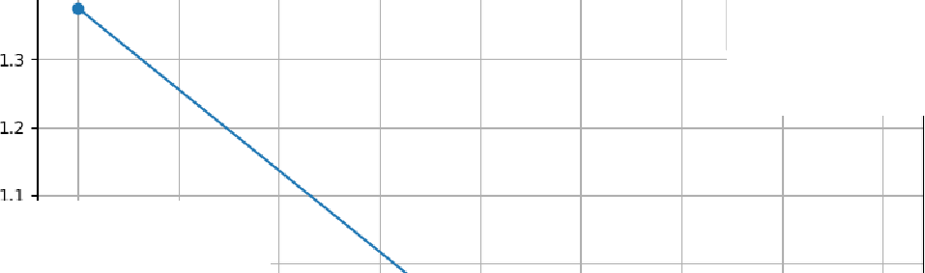
-+T-raining Loss
-+- Validation Loss
�
1.0

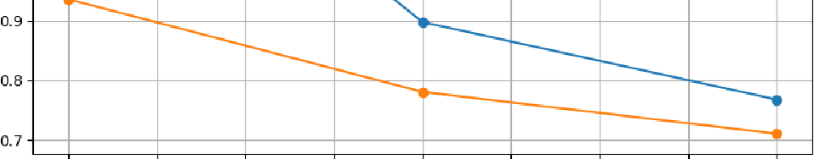

1.00 1.25 1.50 1.75 2.00
Epoch
2.25 2.50 2.75 3.00

EfficientNetBO - Training vs Validation Loss
,_,��---------�-------------�---�
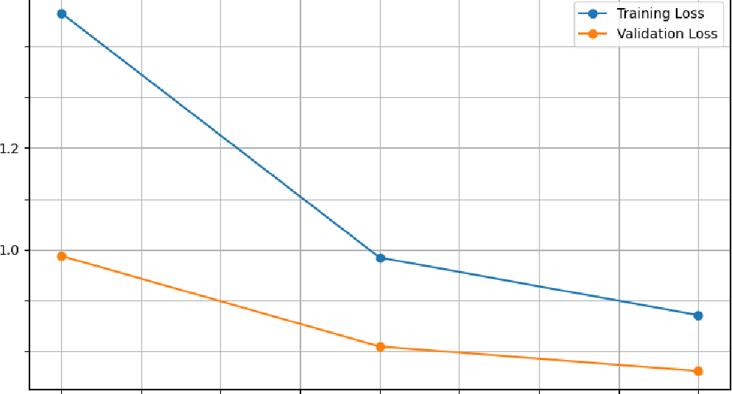
1.4
1.3
_9 1.1
0.9
O.B

1.00 1.25 1.50 1.75 2.00
Epoch
2.25 2.50 2.75 3.00


AlexNet - Confusion Matrix

airplane 0

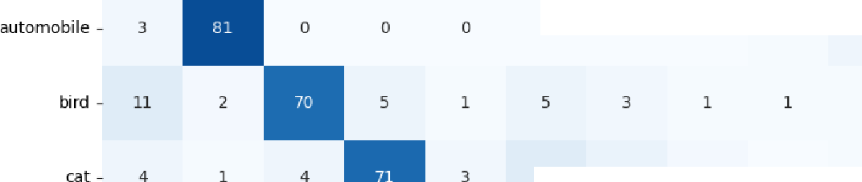
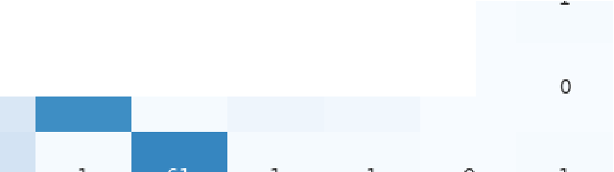
80
0
4
1
11
0
�u
�'"
0
dog -
17

60

40

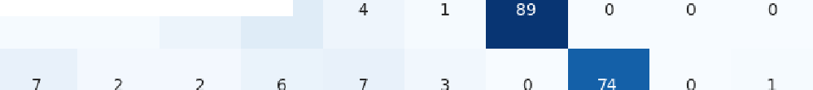
frog -
11

horse -
-20

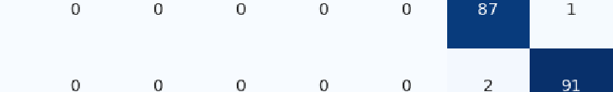
ship - 0

truck - 14 0
.
,g

� - 0

.C .!a " 1§

C. u
�

_;s :c
e-
I
·a
� :g: c

Predicted Class

VGG16 - Confusion Matrix

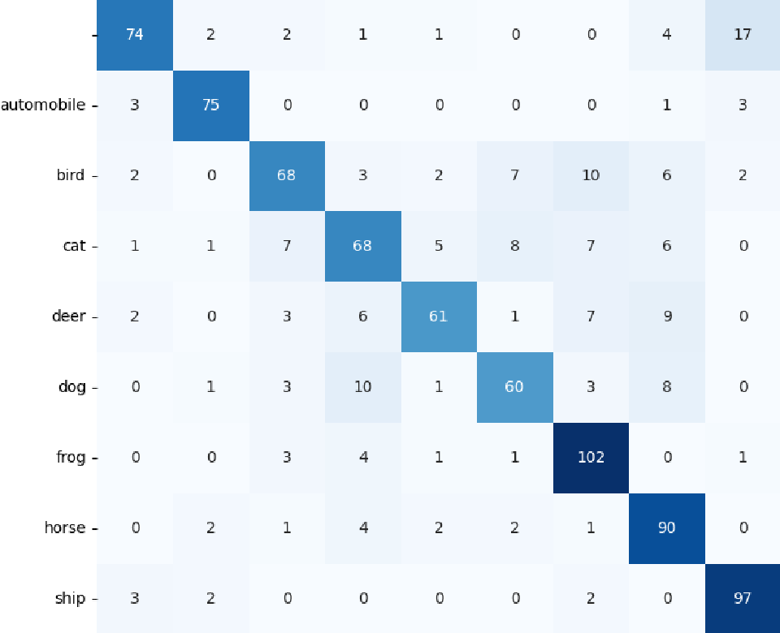
100
airplane

80

60

40

truck -

. 12
ero-
a

.g

Predicted Class

ResNet50 - Confusion Matrix
-20

-o

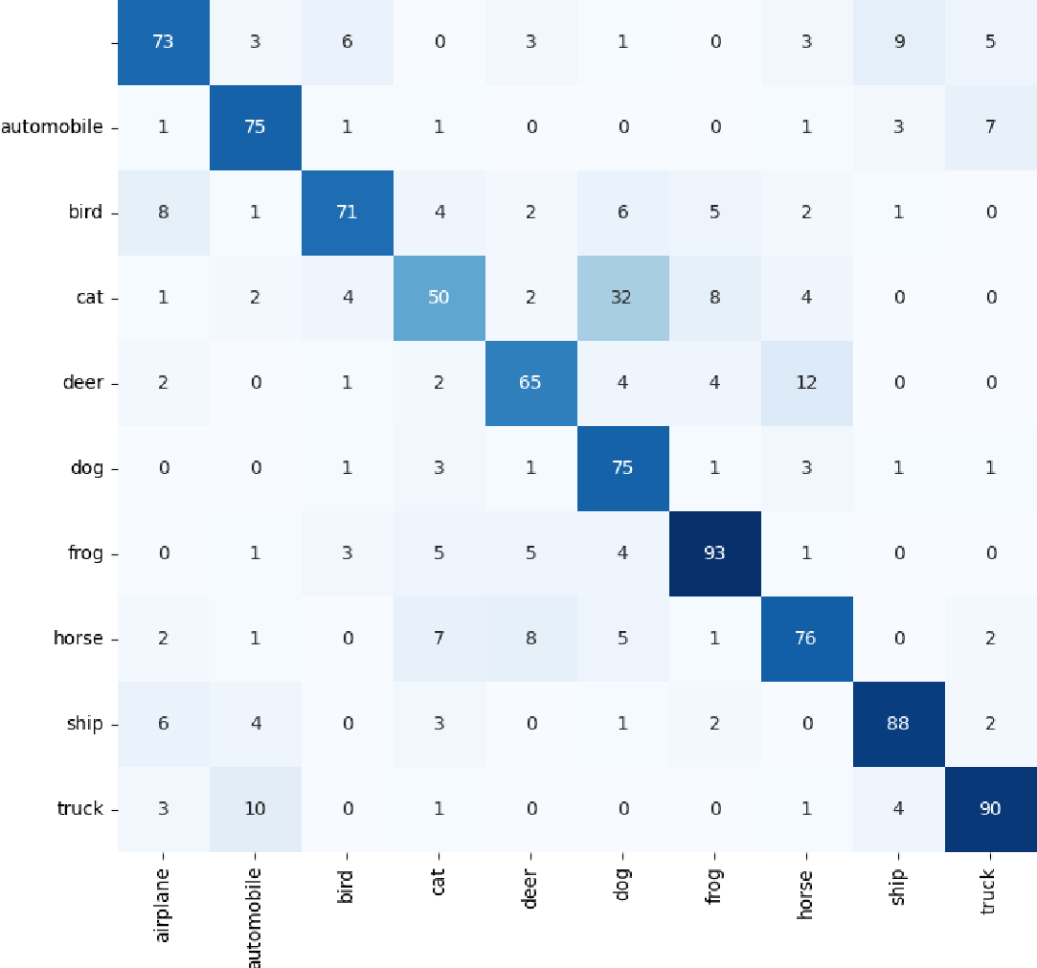
80
airplane

60

40

-20

-o

Predicted class

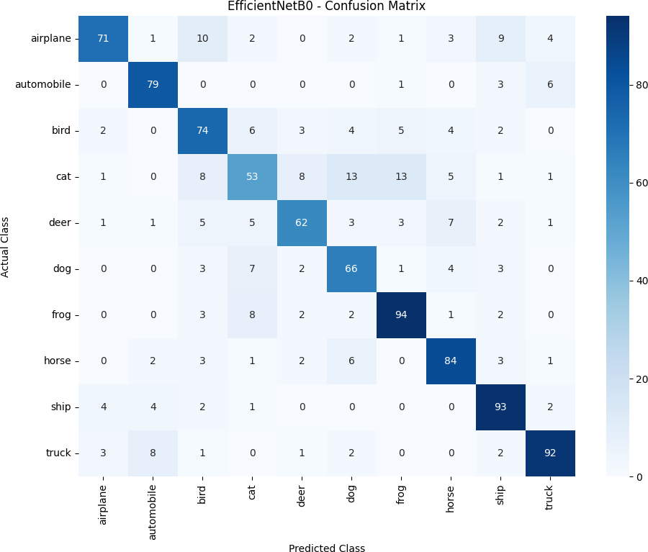

CLASSIFICATION REPORT: AlexNet

=====================================

precision recall f1-score support

airplane 0.67 0.78 0.72 103

automobile 0.70 0.91 0.79 89
accuracy 0.76 1000

macro avg 0.77 0.76 0.76 1000

weighted avg 0.77 0.76 0.76 1000

CLASSIFICATION REPORT: VGG16

=====================================

bird | 0.77 | 0.70 | 0.73 | 100 precision recall f1-score support
cat | 0.56 | 0.69 | 0.62 | 103
deer | 0.77 | 0.64 | 0.70 | 90 airplane 0.86 0.72 0.78 103
dog | 0.74 | 0.71 | 0.73 | 86 | automobile | 0.79 | 0.84 | 0.82 | 89
frog | 0.86 | 0.79 | 0.82 | 112 | bird | 0.78 | 0.68 | 0.73 | 100
horse | 0.91 | 0.73 | 0.81 | 102 | cat | 0.71 | 0.66 | 0.68 | 103
ship | 0.88 | 0.82 | 0.85 | 106 | deer | 0.84 | 0.68 | 0.75 | 90
truck | 0.85 | 0.83 | 0.84 | 109 | dog | 0.76 | 0.70 | 0.73 | 86
 |  |  |  |  | frog | 0.77 | 0.91 | 0.84 | 112

horse 0.73 0.88 0.80 102

ship 0.78 0.92 0.84 106

truck 0.88 0.84 0.86 109

accuracy 0.79 1000

macro avg 0.79 0.78 0.78 1000

weighted avg 0.79 0.79 0.78 1000

CLASSIFICATION REPORT: ResNet50

=====================================
accuracy 0.76 1000

macro avg 0.76 0.76 0.75 1000

weighted avg 0.76 0.76 0.75 1000

CLASSIFICATION REPORT: EfficientNetB0

=====================================

precision recall f1-score support

airplane 0.87 0.69 0.77 103

automobile 0.83 0.89 0.86 89

precision recall f1-score support bird |  |  |  |  |  | 0.68 | 0.74 | 0.71 | 100
cat |  |  |  |  |  | 0.64 | 0.51 | 0.57 | 103
airplane 0.76 0.71 0.73 103 deer |  |  |  |  |  | 0.78 | 0.69 | 0.73 | 90
automobile | 0.77 | 0.84 | 0.81 | 89 | dog | 0.67 | 0.77 | 0.72 | 86
bird | 0.82 | 0.71 | 0.76 | 100 | frog | 0.80 | 0.84 | 0.82 | 112
cat | 0.66 | 0.49 | 0.56 | 103 | horse | 0.78 | 0.82 | 0.80 | 102
deer | 0.76 | 0.72 | 0.74 | 90 | ship | 0.78 | 0.88 | 0.82 | 106
dog | 0.59 | 0.87 | 0.70 | 86 | truck | 0.86 | 0.84 | 0.85 | 109
frog | 0.82 | 0.83 | 0.82 | 112
horse | 0.74 | 0.75 | 0.74 | 102 | accuracy |  |  | 0.77 | 1000
ship | 0.83 | 0.83 | 0.83 | 106 | macro avg | 0.77 0.77 0.76 1000
truck | 0.84 | 0.83 | 0.83 | 109 | weighted avg |  | 0.77 | 0.77 | 0.77 | 1000

CONCLUSION

Best performing model: VGG16 Fastest model: AlexNet

